Trust, Knowledge Sharing, and ICT Effects on Distributed Agile Performance in Pakistan
Sanober Fatima, Mazni Omar and Mazida Ahmad
Institute for Advanced and Smart Digital Opportunities (IASDO), School of Computing, Universiti Utara Malaysia, Sintok, Kedah, Malaysia
fatimasanober28@gmail.com (Corresponding author)
mazni@uum.edu.my
mazida@uum.edu.my
https://doi.org/10.34190/ejkm.24.2.4467
An open access article under CC Attribution 4.0
Abstract: The rising adoption of distributed agile teams has reshaped the global software industry. However, sustaining their effectiveness remains a significant challenge, particularly in the rapidly evolving Information Technology (IT) industry. While trust dynamics, knowledge sharing process, and Information and Communication Technology (ICT) are extensively recognized as essential facilitators of collaboration, their interconnections in distributed agile teams remain underexplored. The present study examined the relationship between Cognitive-based Trust (CBT) and Affect-based Trust (ABT) and key knowledge-sharing processes, including Socialization (SOC) and Externalization (EXT), and assessed their mediation role in relation to Agile Distributed Team Performance (ADTP). The study also investigated the moderating role of ICT in these relationships. To address the objectives, a quantitative, cross-sectional research design was adopted. Data were collected through a survey using structured questionnaires from ADTP associated with the IT industry of Pakistan. Using purposive sampling, three major cities, namely Lahore, Karachi, and Islamabad, were selected. As a result, 193 responses were deemed usable for data analysis. The study utilized Structural Equation Modelling (SEM) to investigate the hypothesized relationships. SPSS 25 and SmartPLS 4 were applied to test hypothesized relationships. The most important findings demonstrate that CBT is significantly associated with both knowledge-sharing processes and team performance, whereas ABT shows weaker or non-significant effects. SOC and EXT are confirmed as key mediators linking trust to ADTP. ICT strengthens EXT but provides limited support for SOC-related processes. By integrating trust theory, selected SECI knowledge conversion processes, and socio-technical perspectives, this study advances understanding of trust and ICT operating through process-specific boundary conditions in distributed agile collaboration. It also provides practical guidance for emerging IT contexts. The findings also have implications for e-learning practices through an emphasis on CBT, knowledge articulation, and the efficient development of ICT in collaborative learning and knowledge-sharing within technology-oriented learning environments. On the other hand, the empirical demonstration of the role of socio-technical enablers in the knowledge-sharing process and its impact on performance in a collaborative learning environment enhances the existing e-learning literature. It also highlights the importance of fostering CBT, improving documentation practices, and aligning ICT use with relational engagement to enhance ADTP.
Keywords: Distributed agile team performance, Cognitive-based trust, Affect-based trust, Socialization, Externalization, Emerging IT industry

Introduction

Distributed Agile Development
In today’s fast-paced IT industry, agility has become essential for managing the increasing complexity of software projects organization are increasingly adopting distributed agile teams to access global talent and deliver solutions efficiently under time constraints (Waheed et al., 2019). Evidence suggests that agile practices enhance productivity and project success in a complex environment (Project Management Institute, 2021).
However, despite these advantages, Distributed Agile Teams (DAT) face significant challenges, including communication and coordination difficulties, fragmented Knowledge-sharing, and limited opportunities for building interpersonal relationships across geographical, cultural, and temporal boundaries (Pinjani & Palvia, 2013; Waheed et al., 2019). These challenges directly affect team performance and highlight the importance of understanding underlying socio-technical mechanisms.

Socio-Technical Enablers of Knowledge-Sharing
Within distributed agile environments, trust plays a critical role in enabling effective collaboration and knowledge-sharing. Trust is conceptualized as CBT, reflecting competence and reliability, and ABT, grounded in emotional bonds (Algood et al., 2023; McAllister, 1995). Both forms of trust influence knowledge-sharing processes, which are central to team coordination and performance.
Knowledge-sharing is commonly understood through the SECI model, where SOC represents tacit knowledge exchange and EXT refers to the conversion of tacit knowledge into explicit forms (Nonaka, Takeuchi & Umemoto, 1996). Within these processes, trust elevates innovativeness and anticipatory problem-solving, fostering a reciprocal cycle in which knowledge-sharing is reinforced (Huber et al., 2016). While these processes are essential in distributed teams, their effectiveness depends on both social and technological conditions.
Although ICT has been widely recognized as an enabler of knowledge-sharing in distributed agile teams, prior research presents mixed and sometimes contradictory findings. On one hand, studies such as Alavi and Leidner (2001) and Lee and Choi (2003) emphasize that ICT enhances knowledge creation, coordination, and organizational performance by facilitating information exchange and collaboration. Similarly, Davidaviciene et al. (2020) and Müller and Antoni (2022) highlight its positive role in improving communication efficiency and supporting knowledge-sharing of distributed teams,
On the other hand, research also suggests that ICT may constrain certain aspects of knowledge-sharing, particularly those involving tacit knowledge and interpersonal trust. For example, Pinjani and Palvia (2013) argue that reliance on computer-mediated communication can weaken social interaction and limit the development of trust in global distributed teams. Likewise, Chowdhury (2005) emphasizes that affect trust, which is essential for sharing complex and tacit knowledge, is difficult to establish in technology-mediated environments.
These contrasting findings indicate that ICT does not operate as a uniformly positive enabler but rather as a context-dependent factor that differentially influences (Tyagi, Sibal and Suri, 2018; Waheed et al., 2019) knowledge-sharing processes. In particular, ICT may effectively support explicit knowledge articulation (externalization) while simultaneously constraining informal, trust-based interactions required for tacit knowledge exchange (socialization). However, prior studies have not sufficiently examined how ICT simultaneously enables and constrains these processes, within a unified framework, particularly in relation to trust and performance outcomes in distributed agile teams and especially within a developing country context (Tyagi, Sibal & Suri, 2018; Waheed et al., 2019).

Context of the Study: Pakistan IT Industry
The IT section in Pakistan, though relatively young, is expanding rapidly and gaining global recognition as software companies increasingly serve international clients. This growth is largely driven by outsourced IT services and offshore development centres established by foreign firms seeking cost-effective solutions (Board of Investment, 2023). However, despite this expansion, project failure rates remain a significant concern.
Prior studies report that a considerable proportion of IT and e-government projects in Pakistan fail or achieve limited success due to issues such as poor project planning, weak coordination, and ineffective management practices (Abbas et al., 2017; Mustaqeem, Khalid & Nabi, 2020). Wafa et al.(2022) indicate that approximately 40% of IT projects fail, while only around 15% of e-government projects are considered successful. These persistent challenges are further linked to inadequate adoption and implementation of agile methodologies, emphasizing the importance of agile practices in addressing the inherent complexity of IT projects (Dhir, Kumar & Singh, 2018).
Figure 1 outlines the issues with agile DAT that lead to high failure rates in IT projects and shows how trust feeds back in improving knowledge-sharing processes. Agile principles 5 and 11 enable reliability and emotional bonding; however, both tacit and explicit knowledge support agile principles 6 and 12. The supportive function of ICT enhances knowledge-sharing processes, subsequently IT project outcomes.
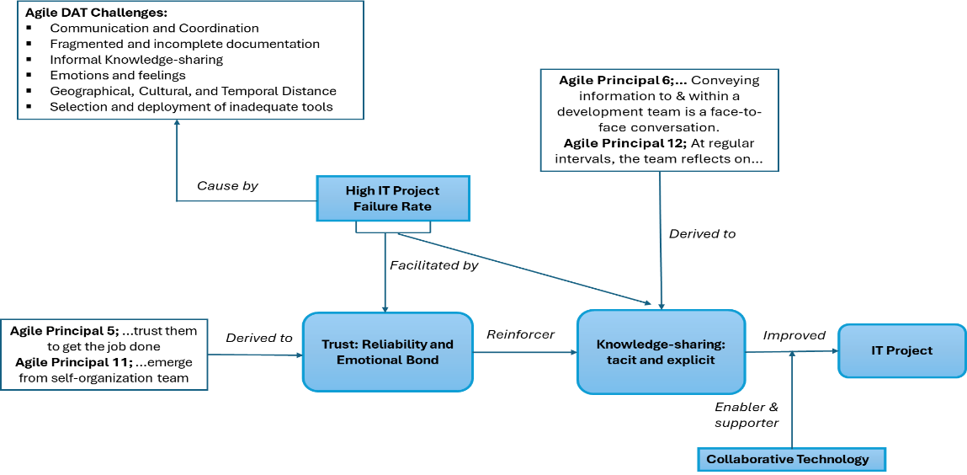
Figure 1: Research Background

Research Gap and Study Contribution
Despite the growing body of research on trust, knowledge-sharing, and ICT, several important gaps remain. Prior studies have largely examined these constructs independently or through direct relationships, with limited attention to their combined effects within integrated mechanisms (Davidavičienė, Al Majzoub & Meidute-Kavaliauskiene, 2020; Müller & Antoni, 2022). In particular, the role of ICT as a boundary condition influencing the indirect relationship between trust and team performance through specific knowledge-sharing processes remains underexplored. Furthermore, existing research presents inconsistent findings regarding the role of ICT, yet these contradictions have not been systematically examined at the process level (Chowdhury, 2005; Pinjani & Palvia, 2013).
To address these gaps, this study integrates trust theory, the SECI model, and socio-technical perspectives to examine how ICT moderates the indirect relationship between trust and performance through knowledge-sharing processes. This approach enables examination of how cognitive-based and affect-based trust influence performance through socialization and externalization, while ICT moderates these relationships (see Figure 2). By conceptualizing mediation and moderation as a linked process, Müller and Antoni (2022), where ICT is a boundary condition that moderates the indirect effects of trust on ADTP through knowledge-sharing processes, this study provides a more comprehensive understanding of how trust, knowledge-sharing, and ICT jointly shape agile distributed team performance.
- Do CBT and ABT influence ADTP?
- Do SOC and EXT mediate the relationship between CBT, ABT, and ADTP?
- Does ICT moderate the relationship between SOC, EXT, and ADTP?
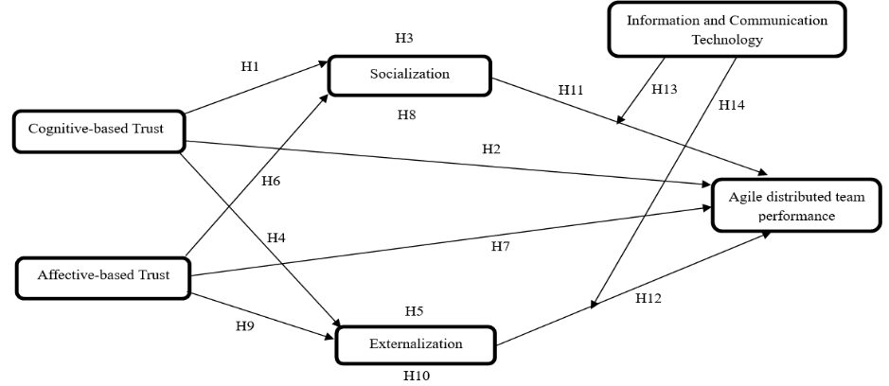
Figure 2: The Conceptual Diagram

Theoretical Background and Literature Review

Theoretical Background
This study is underpinned by the SECI model of knowledge-sharing (Nonaka, Takeuchi and Umemoto, 1996), which describes the processes through which tacit and explicit knowledge are transformed. These processes involve strong interpersonal interaction elements and are closely linked to the current research goal of exploring trust dynamics and ICT determinants of knowledge-sharing and ADTP. Notably, the SECI model allows for the process-level analysis of knowledge conversion and its efficiency and constraints, enabling the identification of boundary conditions in trust and ICT-enabled collaborative processes.

Cognitive-based Trust, Socialization, and Agile Distributed Team Performance
In South Asian contexts, particularly Pakistan, the adoption of agile methodologies in distributed teams faces structural challenges, including cultural differences, temporal separation, and limited face-to-face interaction, all of which constrain trust development (Wahbeh et al., 2024). While McAllister (1995) conceptualizes CBT as a rational evaluation of reliability and competence, this perspective is largely grounded in co-located settings and provides limited insight into performance dynamics in agile distributed environments.
Existing literature suggests that trust facilitates communication and knowledge-sharing (Politis, 2003). Yet these studies remain behaviorally oriented, offering a limited explanation of how such interactions translate into ADTP. Similarly, SOC, as a tacit knowledge-sharing process, relies on shared experiences and informal interaction, conditions that are inherently constrained in distributed agile settings. Although agile practices (e.g., stand-ups and retrospectives) attempt to replicate these interactions (Legood et al., 2023) and framework such as Tyagi , Sibal and Suri (2018) emphasize the importance of trust and tacit knowledge in agile environments, these contributions remain largely conceptual and lack empirical validation in distributed agile contexts.
Empirical findings on CBT and tacit knowledge-sharing are also contextually fragmented. For example, Holste and Fields (2010) and Capestro et al. (2024) emphasize knowledge exchange in non-agile or manufacturing contexts, while Umar et al. (2023) report positive trust–knowledge relationships in academic settings. These variations suggest that trust–knowledge dynamics are context-dependent, yet prior research has not adequately examined their implications for ADTP in agile distributed teams (Buvik & Tkalich, 2022).
Accordingly, this study addresses this gap by proposing that CBT enhances socialization and, in turn, improves ADTP through better shared understanding, coordination, and task reliability in distributed members. Furthermore, CBT is expected to support both tacit (SOC) and explicit (EXT) knowledge processes, providing a more comprehensive explanation of performance outcomes. This research hypothesized that:
H1: There is a significant positive relationship between CBT and SOC among ADTP.
H2: There is a significant positive relationship between CBT and ADTP.
H3: SOC mediates the relationship between CBT and ADTP.
H4: There is a significant positive relationship between CBT and EXT.

Cognitive-based Trust, Externalization, and Agile Distributed Team Performance
EXT refers to the conversion of tacit knowledge into explicit, shareable forms; however, this process remains inherently challenging due to the experiential nature of tacit knowledge. While agile teams rely on digital repositories (e.g., Confluence, JIRA, Wikis) to support knowledge codification. Prior research (Tyagi , Sibal and Suri ,2018), largely emphasizes tool availability rather than the conditions under which effective externalization occurs in distributed environments.
Trust has been identified as a critical enabler of coordination and knowledge-sharing, yet its role in externalization remains insufficiently theorized. For instance, Alami, Krancher and Paasivaara (2022) highlight the role of trust in fostering psychological safety and coordination in agile software teams, while Buvik and Tkalich (2022) demonstrate its strong influence on performance in distributed work contexts. However, both studies stop short of explaining how CBT facilitates the articulation of tacit knowledge into structured, reusable forms, particularly in agile distributed teams.
Empirical evidence suggests that CBT has a stronger association with both tacit and explicit knowledge processes compared to affect-based trust (Chen et al., 2021), indicating its importance in contexts requiring clarity, reliability, and structured communication. Despite this, prior research has not sufficiently linked CBT-driven externalization to ADTP.
Accordingly, this study argues that CBT enhances externalization by enabling teams to effectively document and reuse knowledge, thereby reducing rework and improving coordination under distributed conditions. In turn, effective externalization is expected to directly contribute to ADTP. Based on this, the study hypothesized:
H4: There is a significant positive relationship between CBT and EXT.
H5: EXT mediates the relationship between CBT and ADTP.
H12: There is a significant positive relationship between EXT and ADTP.

Affect-based Trust, Socialization, and Agile Distributed Team Performance
ABT refers to confidence grounded in emotional bonds and interpersonal relationships developed through shared experiences (Legood et al., 2023; McAllister, 1995), which may encourage openness and willingness to share knowledge among team members rather than directly shaping task performance. Chowdhury (2005) argues that ABT is an emotional and social tie between individuals, facilitating the exchange of complex knowledge through shared mental models and mutual understanding. Implementing and sustaining agile methodologies such as daily stand-ups, face-to-face communication, sprint ceremonies, and pair programming in distributed agile teams is challenging. However, the presence of emotional connections and interpersonal interactions among team members may mitigate coordination constraints, facilitate the successful transfer of tacit knowledge and increase the likelihood that individuals will share information.
Scholars hold varying perspectives on the impact of ABT on tacit knowledge-sharing. For example, Swift and Hwang (2013) claim that ABT is more critical than CBT in the exchange of social knowledge. Similarly, Holste and Fields (2010) argue that ABT, emotional trust, plays a more substantial role in influencing the willingness to share tacit knowledge rather than its application. In contrast, Chen et al. (2021) suggest that emotional trust is less strongly linked to both tacit and explicit knowledge, in contrast to CBT. Capestro et al. (2024) align with this viewpoint, claiming that emotional trust plays a minimal role in shaping technological and organizational factors underlying tacit knowledge-sharing. Consequently, emotional trust may function as a contextual motivator influencing individuals’ readiness to engage in tacit knowledge exchange rather than as a direct performance driver. From a performance perspective, ABT contributes to ADTP primarily by strengthening SOC processes that support interpersonal coordination, psychological safety, and willingness to engage in collaborative work. Based on the discussion, the study hypothesized:
H6: There is a significant positive relationship between ABT and SOC.
H7: There is a significant positive relationship between ABT and ADTP.
H8: SOC mediates the relationship between ABT and ADTP.

Affect-based Trust, Externalization, and Agile Distributed Team Performance
EXT is the conversion of tacit knowledge into explicit forms and is inherently complex, requires more than interpersonal closeness. While ABT fosters openness and willingness to share, its role in enabling externalization remains inconsistent and underexplored. For example, Holste and Fields (2010) suggested that weak emotional ties limit knowledge articulation; however, strong emotional bonds alone do not ensure effective codification.
Recent studies indicate that ABT is insufficient in isolation and depends on enabling conditions such as psychological safety. Alami, Krancher and Paasivaara (2022) show that emotional trust supports knowledge t processes only in psychologically safe environments, while Ahmad (2025) and Santana et al. (2025) highlight that a supportive communication climate is necessary for transforming trust into explicit knowledge-sharing. This suggests that ABT enhances willingness, but not necessarily the ability to externalize knowledge.
These inconsistencies indicate that the ABT–EXT relationship is context-dependent, and its link to agile ADTP remains insufficiently examined. Accordingly, ineffective externalization, particularly in low psychological safety contexts, may constrain performance by limiting knowledge reuse. Based on this, the study hypothesized that:
H9: There is a significant positive relationship between ABT and EXT.
H10: EXT mediates the relationship between ABT and ADTP.

The Relation of ICT between Socialization, Externalization, and Agile Distributed Team Performance
While ICT is widely recognized as an enabler of knowledge-sharing in distributed agile teams, existing literature presents contradictory evidence regarding its effectiveness. Prior studies, e.g., (Alavi and Leidner, 2001; Davidavičienė, Al Majzoub and Meidute-Kavaliauskiene, 2020; Lee and Choi, 2003; Müller and Antoni, 2022) largely adopt a technology-centric perspective, emphasizing ICT’s role in enhancing communication, coordination, and performance. However, this view overlooks important process-level differences and contextual conditions.
In contrast, other studies suggest that ICT may simultaneously enable and constrain knowledge-sharing. For example, ICT facilitates explicit knowledge articulation through EXT, particularly via asynchronous communication (Tyagi , Sibal & Suri, 2018). Yet it may hinder SOC, as computer-mediated communication reduces social richness and limits the development of affect-based trust, which is essential for tacit knowledge exchange (Chowdhury, 2005; Pinjani & Palvia, 2013). These conflicting findings indicate that ICT is not a uniform enabler but a contingent factor whose impact varies across knowledge processes.
Despite this, prior research has not sufficiently examined how ICT differentially shapes socialization and externalization within a unified framework, nor how it conditions their relationship with performance outcomes. This gap is particularly evident in distributed agile contexts and developing countries, where communication practices and ICT usage may differ (Waheed et al., 2019). Accordingly, this study adopts a contingency perspective, proposing that ICT moderates the effectiveness of trust-based knowledge-sharing processes in influencing ADTP, rather than directly enhancing performance. The study hypothesized:
H13: The mediating effect of SOC in the relationship between CBT, ABT, and ADTP varies across levels of ICT.
H14: The mediating effect of EXT in the relationship between CBT, ABT, and ADTP varies across levels of ICT.

Methods and Materials

Research Design and Sampling Strategy
Based on the positivist philosophy, the present research adopts a quantitative, cross-sectional research design to study the hypothesized relationships (Trochim et al., 2011). The main objective of the study was to examine the influence of ABT and CBT on ADTP with the mediation of SOC and EXT and the moderating effect of ICT. Therefore, a quantitative approach seemed suitable for studying the research objective. The study population contains 10,253 IT-registered companies in Pakistan. The Securities and Exchange Commission of Pakistan (SECP) obtained the list of firms. Three metropolitan cities, namely Lahore, Islamabad, and Karachi, were selected due to the dense population, which accounts for 34.78%, 26.1%, and 24.6%, respectively. In addition, these three cities account for 85.4% of all SEP-registered IT companies in Pakistan (Ministry of Information Technology and Telecommunication, 2020).
The study employed a purposive sampling technique to collect the data due to the absence of an updated and complete list of IT companies. Furthermore, the purposive sampling was found suitable because it properly aligned with the study objectives. In the same context, Vehovar, Toepoel and Steinmetz (2016) suggested that purposive sampling increases the validity and precision of findings. Furthermore, IT companies were selected based on two inclusive criteria. Firstly, IT companies that have adopted agile software development have organized into distributed teams. Moreover, the company's headquarters (HQs) should be in Pakistan, with distributed teams operating in various countries. Secondly, IT companies with at least two to three years of experience were selected. The reason for choosing two to three years is that the respondents would have sufficient time to build trust among distributed agile teams. Studies have shown that trust is not an instantaneous process, but rather a gradual and cumulative one that requires an ongoing process.
Additionally, the study selected developers, Scrum masters/project managers, and testers because they represent the core functional roles in Agile distributed teams. Developers contribute to knowledge creation and sharing, Scrum Masters/project managers facilitate coordination and trust, and testers ensure quality and continuous feedback. Together, these roles capture the technical, managerial, and quality dimensions of Agile teamwork, providing a comprehensive and representative view of team processes, collaboration, and performance. These roles directly influence knowledge-sharing processes and trust dynamics, supporting interpretation of the study’s findings. Since this study employed a cross-sectional design, the findings captured relationships at a single point in time and do not allow for causal or longitudinal interpretations of trust development.

Data Collection Process
The study employed a self-administered, structured questionnaire to obtain responses through a survey technique. Researchers commonly adopt this approach in areas where information needs to be gathered from a broad audience (Keeter et al., 2006). In this way, purposive sampling allows researchers to use their professional and personal contacts to gain access to the software companies. In doing so, a formal request was submitted to the Admin/HR department of the software houses, requesting approval to conduct the study. This study initiated the actual data collection process once it was granted. Data collection was conducted over a period of approximately six months. Online questionnaires were distributed via email and professional contacts, with follow-up reminders issued to improve response rates.
The study employed an online and printed questionnaire to gain the maximum responses. Respondents were provided with a detailed briefing on the academic nature of the study alongside the questionnaire to ensure ethical compliance. Additionally, the study assured respondents that their identities and responses would remain confidential. Beyond this, the study clarified that participation was voluntary, and respondents could withdraw at any time during the data collection process without providing justification. Accordingly, the researchers also obtained informed consent in both oral and written forms.
G*Power was used for sample size calculations. The software is widely used to determine sample size in social science research (Rahman, 2023). Consequently, based on G*Power calculations, a minimum sample size of 134 respondents was required. However, approximately 250 online questionnaires were distributed to IT professionals, and 218 questionnaires were returned; among these, twenty-five were excluded due to missing or incomplete data. Ultimately, 193 usable responses were obtained, representing a 76.6% response rate, and were adequate for conducting the planned statistical analyses and supporting reliable inferences.

Measurement Instrument
The study used a survey based on a 5-point Likert scale (1 = "strongly disagree" to 5 = "strongly agree") to assess 30 items of six constructs. The study has adapted the instrument from earlier recognized investigations. Additionally, CBT and ABT were measured using a 4-item scale of Kanawattanachai and Yoo (2002). Each construct was operationalized to capture respondents’ perceptions of trust, knowledge-sharing processes, ICT support, and ADTP within digitally mediated work settings. To examine reliability, CBT showed α =0.87, and ABT showed α =0.72, which were used in earlier studies to assess the trust dynamic nature in high and low performance of distributed teams. Similarly, SOC and EXT were adapted from the 4-item scale of Schulze and Hoegl (2008). Creating relevance for the study, previous studies have reported Cronbach alpha values for SOC and EXT,0.83 and 0.78, respectively. These studies examined the product innovation process of the pre-project phase of new idea development. Finally, ICT and ADTP were measured using a 5-item scale (Lurey & Raisinghani, 2001). Previously, empirical investigations found the challenges of effectiveness among distributed teams and have also reported Cronbach’s alpha above-threshold values of ICT and ADTP, 0.82 and 0.79, respectively. The complete survey instrument is provided in Appendix A.

Analytical Approach
The study applied the PLS-SEM, one of the latest and most comprehensive approaches, using the SmartPLS 4 application. The PLS-SEM technique is well-suited for a limited sample size, as it does not require a large dataset for analysis. Similarly, PLS-SEM does not require data normality and may manage unobservable constructs. SEM is particularly suitable for examining complex relationships involving mediation and moderation among latent variables. Its primary advantage lies in the ability to simultaneously estimate multiple interdependent relationships; however, PLS-SEM emphasizes prediction and does not provide global goodness-of-fit indices comparable to covariance-based SEM. These limitations were considered during results interpretation (Hair et al., 2019). Consistent with moderated mediation testing principles, the mediation and moderation effects were tested following established SEM guidelines, where interaction terms (ICT × SOC and ICT × EXT) were constructed using the product indicator approach with mean-centred variables to reduce multicollinearity (Müller, Judd & Yzerbyt, 2005).

Findings and Interpretations
The IBM SPSS Statistics version 29.0.2.0 (20) software was used to clean the study data before data analysis by examining missing values, data normality (to assess distributional assumptions), outliers, Harman's single-factor test for common method bias, and multicollinearity through VIF values. A SmartPLS 4 two-step data assessment and hypotheses testing approach was employed to investigate the measurement model and structural model hypotheses and their prediction (Henseler, Ringle & Sarstedt, 2015). The data were gathered from 193 valid respondents from various agile distributed teams, and bootstrapping (10,000 resamples) was applied to assess the significance of direct, indirect (mediation), and interaction (moderation) effects, consistent with moderated mediation testing procedures (Hair et al., 2019).

Demographics
The study revealed that most respondents were male, accounting for 83.9% of the overall sample. A large portion of the respondents' ages fell between 31 and 40, and 59.5% of respondents held a master's degree. Moreover, a significant portion of respondents, 77.2%, were using the Scrum Agile framework, followed by Extreme Programming (XP). Most of them were software developers, comprising 26.4%. Furthermore, most data were collected from Karachi city, constituting 61.7 %, where the largest number of distributed teams was between 11 and 15, accounting 26.9%, followed by teams 16-20, which accounted for 22.3 % of the total sample. Table 1 presents demographic characteristics.
Table 1: Demographic Characteristics
Demographics | Categories | Frequency | Percentage
Gender | Male  Female  Other | 162  31  0 | 83.9  16.1  0
Age | 20 to 30 years  31 to 40 years  41 to 60 years | 43  114  36 | 22.3  59.1  18.7
Qualification | PhD  Masters  Graduation  Other | 8  115  70  0 | 4.15  59.5  36.3  0
Agile Framework | Scrum  Extreme Programming (XP)  Crystal  DSDM  Lean development  Scaled Agile Framework  Other | 149  33  0  0  0  11  0 | 77.2  17.1  0  0  0  5.7  0
Title of position | Project Owner  Project Leader/Team Leader  Project Manager  Software Developer  Software Testers  System Administrator  Consultant | 21  25  32  51  22  6  36 | 10.9  13  16.6  26.4  11.4  3.1  18.7
Team location | Karachi  Lahore  Islamabad | 119  43  31 | 61.7  22.3  16.1
Number of distributed teams | 6-10  11-15  16-20  21-30  More than thirty | 35  52  43  35  21 | 18.1  26.9  22.3  18.1  10.9

Measurement Model
The measurement model was evaluated using reliability, convergent validity (AVE), and discriminant validity (HTMT) criteria. To confirm the internal consistency reliability, the study used factor loading, which achieved the required threshold of 0.50. The study's constructs achieved a Cronbach's alpha value above 0.70, indicating a standard level of reliability. Similarly, the table.2 presents the study construct AVE (Average variance extracted), which met the threshold value above 0.50. The internal consistency and reliability were confirmed by achieving the study construct composite reliability values, which were likewise greater than 0.70 (Chin, 1998; Hair et al., 2019).
Table 2: Measurement Model
No | Construct | Loadings | Alpha | CR | AVE
1 | Cognitive-Based Trust |  | 0.731 | 0.832 | 0.553
1 | CBT1 | 0.759 | 0.731 | 0.832 | 0.553
1 | CBT2 | 0.746 | 0.731 | 0.832 | 0.553
1 | CBT3 | 0.770 | 0.731 | 0.832 | 0.553
1 | CBT4 | 0.698 | 0.731 | 0.832 | 0.553
2 | Affect-Based Trust |  | 0.862 | 0.906 | 0.706
2 | ABT1 | 0.864 | 0.862 | 0.906 | 0.706
2 | ABT2 | 0.840 | 0.862 | 0.906 | 0.706
2 | ABT3 | 0.825 | 0.862 | 0.906 | 0.706
2 | ABT4 | 0.832 | 0.862 | 0.906 | 0.706
3 | Socialization |  | 0.781 | 0.859 | 0.603
3 | SOC1 | 0.767 | 0.781 | 0.859 | 0.603
3 | SOC2 | 0.790 | 0.781 | 0.859 | 0.603
3 | SOC3 | 0.743 | 0.781 | 0.859 | 0.603
3 | SOC4 | 0.805 | 0.781 | 0.859 | 0.603
4 | Externalization |  | 0.770 | 0.852 | 0.590
4 | EXT1 | 0.773 | 0.770 | 0.852 | 0.590
4 | EXT2 | 0.765 | 0.770 | 0.852 | 0.590
4 | EXT3 | 0.807 | 0.770 | 0.852 | 0.590
4 | EXT4 | 0.727 | 0.770 | 0.852 | 0.590
5 | Information and Communication Technology |  | 0.759 | 0.838 | 0.510
5 | ICT1 | 0.681 | 0.759 | 0.838 | 0.510
5 | ICT2 | 0.708 | 0.759 | 0.838 | 0.510
5 | ICT3 | 0.673 | 0.759 | 0.838 | 0.510
5 | ICT4 | 0.735 | 0.759 | 0.838 | 0.510
5 |  | 0.768 | 0.759 | 0.838 | 0.510
6 | Agile Distributed Team Performance |  | 0.913 | 0.928 | 0.590
6 | ADTP1 | 0.797 | 0.913 | 0.928 | 0.590
6 | ADTP2 | 0.777 | 0.913 | 0.928 | 0.590
6 | ADTP3 | 0.730 | 0.913 | 0.928 | 0.590
6 | ADTP4 | 0.732 | 0.913 | 0.928 | 0.590
6 | ADTP5 | 0.779 | 0.913 | 0.928 | 0.590
6 | ADTP6 | 0.780 | 0.913 | 0.928 | 0.590
6 | ADTP7 | 0.706 | 0.913 | 0.928 | 0.590
6 | ADTP8 | 0.808 | 0.913 | 0.928 | 0.590
6 | ADTP9 | 0.794 | 0.913 | 0.928 | 0.590

Discriminant Validity
Discriminant validity was assessed using the Heterotrait-Monotrait Ratio (HTMT), which is a comparison of the square root of the Average Variance Extracted (AVE) for all constructs to their inter-construct correlations (Fornell & Larcker, 1981). The HTML values are considered unsatisfactory if they exceed the 0.85 threshold (Kline et al., 2012). Another study suggested that the acceptable threshold is greater than 0.90. However, the findings are presented in Table 3, which shows that HTMT values are below the 0.85 threshold, hence meeting the standard of discriminant validity criteria.
Table 3: Discriminant Validity
Construct | CBT | ABT | SOC | EXT | ICT | ADTP
Cognitive-Based Trust | _
Affect-Based Trust | 0.660 | _
Socialization | 0.808 | 0.658 | _
Externalization | 0.720 | 0.421 | 0.761 | _
ICT | 0.544 | 0.461 | 0.567 | 0.655 | _
Agile Distributed Team Performance | 0.800 | 0.641 | 0.806 | 0.828 | 0.690 | _

Structural Model
This study performed the structural model assessment following the measurement model. Figure 3 shows the structural model diagram of the study, while Table 4 presents the results of all significant hypotheses. Hypothesis 1 shows a direct and significant positive association between CBT and SOC (β =0.623, p < 0.001). Hypothesis 2 proposed a positive relationship between CBT and ADTP (β =0.243, p < 0.001). Similarly, Hypothesis 4 shows a positive relationship between CBT and EXT (β =0.511, p < 0.001). The findings fully support Hypothesis 6, indicating a positive association between ABT and SOC (β =0.257, p < 0.001). Likewise, Hypothesis 7 claims a positive relationship between ABT and ADTP (β =0.133, p < 0.001). Substantially undertaken Hypotheses 11 SOC to ADTP (β =0.269, p < 0.001) and 12 EXT to ADTP (β =0.287, p < 0.001) also support positive relationships in the study. Among all direct hypotheses, only one was rejected, indicating a non-significant relationship between ABT and EXT (β =0.953, p < 0.001). Moreover, the empirical analysis confirms Hypothesis 3, a positive mediating association of SOC between CBT and ADTP (β = 0.149, p < 0.001). Similarly, Hypothesis 5 relationship examining the mediating role of EXT between CBT and ADTP (β =0.147, p < 0.001) and Hypothesis 8 relationship of SOC between ABT and ADTP (β =0.068, p < 0.001) support a positive mediating association. Furthermore, the findings confirm Hypothesis 14, confirming the moderate effect of ICT on the relationship between EXT and ADTP (β = 0.330, p < 0.001). Conversely, Hypothesis 13 showed that the moderating effect of ICT between SOC and ADTP (β =-0.310, p < 0.001) weakened the relationship. Figure 4 presents the structural model results, including path coefficients (β), R² values, significant and non-significant relationships, and boundary conditions discussed in subsequent sections.
Table 4: Direct, Mediation, and Moderation Relationships
Hypothesis | Path | Path Coefficient | t-value | BCI LL | BCI UL | Decision
H1 | CBT → SOC | 0.623 | 7.711 | 0.464 | 0.782 | Accepted
H2 | CBT → ADTP | 0.243 | 4.479 | 0.135 | 0.351 | Accepted
H3 | CBT → SOC →ADTP | 0.149 | 3.415 | 0.065 | 0.233 | Accepted
H4 | CBT → EXT | 0.511 | 7.426 | 0.376 | 0.646 | Accepted
H5 | CBT → EXT → ADTP | 0.147 | 3.806 | 0.073 | 0.221 | Accepted
H6 | ABT → SOC | 0.257 | 3.854 | 0.128 | 0.386 | Accepted
H7 | ABT → ADTP | 0.133 | 2.416 | 0.027 | 0.239 | Accepted
H8 | ABT → SOC →ADTP | 0.068 | 3.149 | 0.025 | 0.111 | Accepted
H9 | ABT → EXT | 0.077 | 0.953 | -0.076 | 0.230 | Rejected
H10 | ABT → EXT → ADTP | 0.021 | 0.023 | -0.024 | 0.066 | Rejected
H11 | SOC → ADTP | 0.269 | 4.333 | 0.147 | 0.391 | Accepted
H12 | EXT → ADTP | 0.287 | 4.882 | 0.173 | 0.401 | Accepted
H13 | ICT → SOC → ADTP | -0.310 | 2.992 | 0.514 | -0.106 | Accepted (Weaken)
H14 | ICT → EXT → ADTP | 0.330 | 3.574 | 0.149 | 0.511 | Accepted (Strengthen)

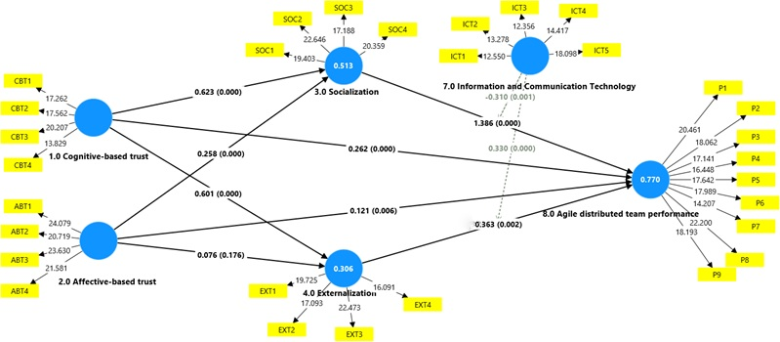
Figure 3: Structural Model
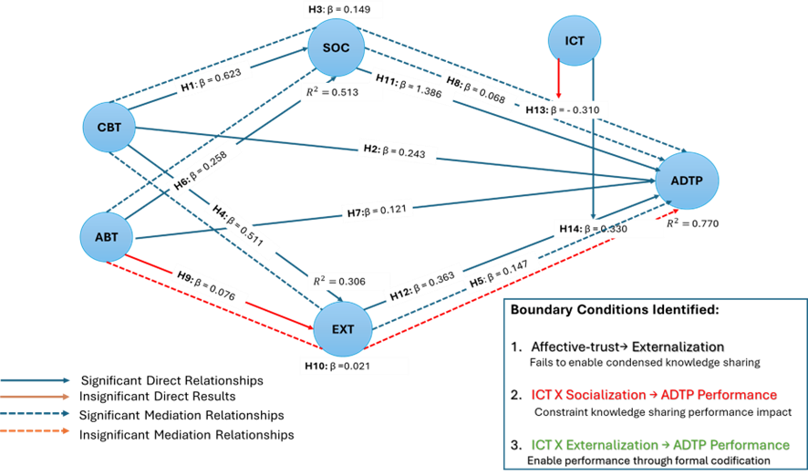
Figure 4: Structural Model Results Including Path Coefficients (β), R² Values, and Significant and Non-significant Relationships, with Identified Boundary Conditions

Explanatory Power of the Model
The structural model was evaluated using path coefficients and the coefficient of determination R² to assess the explanatory power. The study employed the PLS technique to establish a desirable standard threshold of R² above 0.10 for all results (Falk and Miller, 1992). Figure 4 presents the R² values of SOC (0.514), EXT (0.305), and ADTP (0.751). Moreover, the study calculated the variance accounted for (VAF) values to examine the indirect effects involving SOC and EXT on ADTP (Hair et al., 2019).
$$VAF=\frac{Indirect effect}{Total effect}$$
CBT → SOC → ADTP
$$VAF=\frac{0.149}{0.243+0.149}=0.380=38\%$$
As shown in Eq. (1), VAF values represent a partial indication (20-80%).
CBT → EXT → ADTP
$$VAF=\frac{0.147}{0.243+0.147}=0.377=37.7\%$$
As shown in Eq. (1), the VAF values represent a partial indication.
ABT → SOC → ADTP
$$VAF=\frac{0.068}{0.133+0.068}=0.338=33.8\%$$
As shown in Eq. (1), the VAF values represent a partial indication.
ABT → EXT → ADTP
$$VAF=\frac{0.021}{0.133+0.021}=0.136=13.6\%$$
As shown in Eq. (1), the VAF values represent no mediation (<20%)
Among the four mediation effects of the study, the VAF findings indicated partial mediation (20% to 80%) of all indirect relationships except for the impact of EXT on ABT and ADTP, which accounted for less than 20% of the variance.

The Moderating Effect of ICT
The study used the SEM technique to analyze the impact of the moderating relationships. The direct relationships between the exogenous variables and the interaction term's relationship with the endogenous construct were analyzed to ascertain the existence of a moderating effect (Hair et al., 2019). The moderator construct ICT weakens the influence of SOC on ADTP while strengthening the impact of EXT on ADTP, demonstrating its varied role in shaping team performance. The findings are illustrated through the graphical representation of the moderator construct ICT at low (solid line) and high levels (dashed line). Figure 5 shows that the positive moderator effect of ICT between EXT and ADTP, indicating that higher ICT levels strengthen the impact of EXT on ADTP.
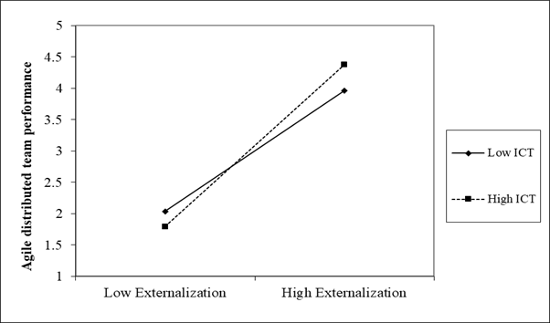
Figure 5: Moderating the Interaction effect of ICT on the Relationships between Externalization and Agile Distributed Team Performance
In contrast, Figure 6 illustrates a negative moderator effect of ICT on SOC and ADTP, indicating that higher levels of ICT attenuate the impact of SOC on ADTP.
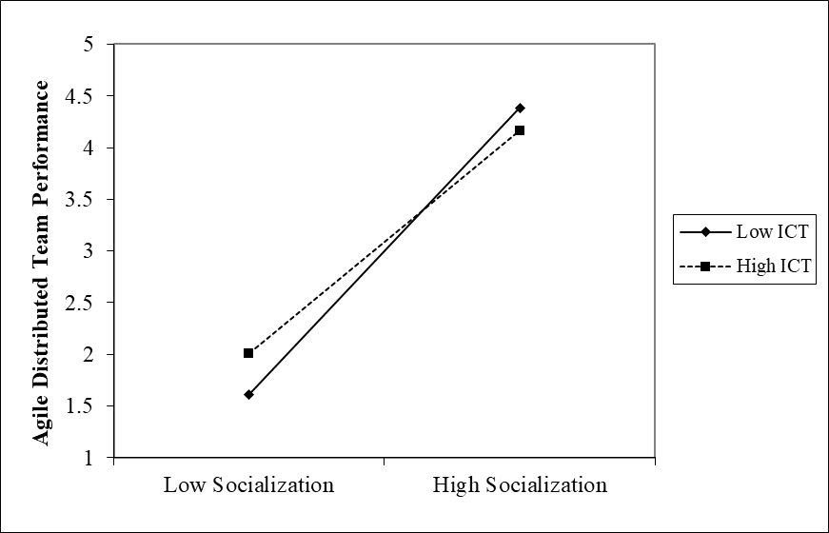
Figure 6: Moderating the Interaction effect of ICT on the Relationships between Socialization and Agile Distributed Team Performance

Discussion
The primary objective of the current research was to investigate the ADTP in IT-based companies in Pakistan, as discussed earlier. Henceforth, driven by the SECI model of KS, the study examines the influence of trust through ABT and CBT on team performance, with ICT tools moderating this relationship.

Cognitive-based Trust, Socialization, Externalization, and Agile Distributed Team Performance
The present study found a positive relationship between CBT and SOC within ADTP. These findings align with past investigations by Capestro et al. (2024) and Tyagi, Sibal and Suri (2018), who reasoned that trust significantly contributes to SOC. This form of trust reinforces coordination and shared understanding through task-focused interaction rather than affective bonding, indicating that the SOC benefits of CBT are bound by competence-driven collaboration. Similarly, CBT was found to have a positive effect on ADTP, demonstrating that trust based on skill, reliability, and ability reduces conflict and reinforces the common goal within distributed teams. This finding is consistent with Khan and Rehman (2025) and Zong and Guan (2025), who emphasize that competence-based trust among team members facilitates seamless teamwork and promotes successful agile projects in the IT industry, particularly through task alignment and execution reliability rather than relational motivation. This suggests that CBT enhances performance where coordination, clarity and role accountability dominate over emotional engagement.
In addition to its direct influence, the mediating effect of SOC between CBT and ADTP underscores that sharing tacit knowledge among distributed members in the presence of skilled and reliable trust boosts the overall team performance. Rather, it must be channeled through SOC processes such as collaborative brainstorming and reciprocal knowledge-sharing, which convert individual expertise into collective coordination capacity. Accordingly, the findings imply that managers should structure interaction through virtual stand-ups, mutual retrospectives, and knowledge exchange meetings. This indicates a boundary condition whereby CBT contributes to performance only when SOC mechanisms are intentionally structured, and interaction is operationally focused. Further, the results demonstrate that CBT is positively associated with EXT.
The findings are supported by earlier investigations (Holste & Fields, 2010). Chen et al. (2021) suggested that team members who perceived mutual expertise are most likely to discuss and record their tacit knowledge explicitly. Agile distributed teams have a stronger tendency among members with high CBT, recording decisions, and knowledge through collaborative repositories (Razzak, Bhuiyan & Ahmed, 2014). Moreover, the mediation effect of EXT between CBT and ADTP enhances performance outcomes, as competence-based trust supports systematic knowledge codification and reuse, strengthening process reliability and reducing execution ambiguity rather than merely stimulating innovation (Buvik & Tkalich, 2022). It indicates that CBT-driven EXT is bounded by formalized documentation practices and does not automatically translate into broader relational learning outcomes.
Conclusively, these findings show that CBT enables SOC and EXT as structured coordination mechanisms, highlighting that its performance contribution is bound by competence-driven collaboration. These findings contribute to the theory by positioning cognitive-based trust as a structural coordination mechanism in distributed agile teams.

Affect-based Trust, Socialization, Externalization, and Agile Distributed Team Performance
The study found that ABT has a positive impact on SOC. This suggests that the emotional bond developed within agile distributed teams enables members to feel free to share their feedback and personal experiences in a supportive environment. This aligns with prior studies (Holste and Fields, 2010; Swift and Hwang, 2013). The present study extends this understanding by demonstrating that the effectiveness of ABT-driven socialization is conditioned by respondent characteristics. Most respondents (59.1%) are mid-career professionals (31-40), emphasizing task efficiency over relational bonding. The dominance of male respondents (83.9%) and technical roles (developers, testers, and Scrum Masters/project managers), which are representative of core agile team functions, further reinforces functional, goal-oriented interaction. These findings indicate that the influence of ABT on SOC is contextually bound; however, in this study, socialization is shaped by task-oriented interaction driven by respondent characteristics rather than purely relational environments. Similarly, ABT was found to have a direct positive association with ADTP, indicating that interpersonal care and bonding increase team cohesion and motivation, leading to improvements in interaction-level performance rather than codified knowledge reuse or execution reliability (McAllister, 1995). Thus, the performance contribution of ABT appears primarily rooted in motivational and relational dimensions rather than process-driven outcomes. ABT is particularly relevant in Pakistan’s high-pressure, deadline-driven IT environment. In this context, ABT serves as a buffer against conflict and coordination breakdown, especially in a distributed setup where peer-to-peer contact is limited.
SOC mediates the ABT-ADTP relationship by enhancing coordination and shared understanding rather than formal knowledge articulation. This mediation pattern suggests that ABT motivates informal engagement but does not support the structured knowledge articulation required for performance. This is particularly evident in teams dominated by mid-career professionals and technical roles, who, according to Generational Cohort Theory Mannheim (1952), prioritize problem-solving interactions over socially embedded knowledge-sharing. By contrast, the study revealed that the relationship between ABT and EXT, as well as the mediating effect of ABT and ADTP, was insignificant.
These findings align with those of Chen et al. (2021), who contend that building emotional trust does not contribute to synthesizing explicit knowledge. Therefore, it constrains distributed team performance through limited EXT rather than diminishing overall effectiveness. This viewpoint is in line with the study of Capestro et al. (2024), who emphasize that knowledge codification is more related to the CBT than ABT relationships. Additionally, affect-based trust alone is insufficient for externalization and must be complemented by psychological safety and a supportive communication climate. In the absence of such conditions, emotional bonding may increase willingness to share, but does not translate into structured documentation and knowledge reuse. This indicates that ABT operates primarily at the interactional level, influencing willingness to share but lacking the structural and cognitive mechanisms required for formal knowledge articulation, which is essential for EXT in distributed agile environments.
The insignificance of the ABT–EXT relationship can be more accurately explained by the demographic composition of the respondents rather than general cultural assumptions. Technical roles require clarity and structured documentation, emphasizing task-oriented communication where ABT does not sufficiently translate into formal knowledge articulation (EXT). This reinforces that in technically driven teams, knowledge articulation is governed more by competence validation than emotional bonding. Mid-career dominance further reinforces task-focused communication over emotional trust. Although ranked as the third fastest-growing IT industry worldwide, the sector continues to face challenges related to coordination, knowledge codification, and process standardization (Dhir, Kumar & Singh, 2018). These patterns remain consistent across major IT hubs such as Karachi, Lahore, and Islamabad. This is also reflected in the sample, where most respondents are from Karachi (61.7%), with representation from Lahore and Islamabad, indicating a shared professional subculture characterized by standardized workflows and ICT-mediated practices rather than location-specific cultural differences. Thus, the ABT–EXT insignificance reflects a structural, context-dependent boundary condition rather than a methodological limitation. These findings contribute to theory by demonstrating that ABT plays a conditional and indirect role in knowledge-sharing, rather than acting as a universal driver of performance in distributed agile teams.

Socialization, Externalization, and Agile Distributed Team Performance
The study affirms that SOC and EXT have a significant positive impact on ADTP. This underscores the role of knowledge-sharing processes in enabling effective coordination and outcomes. The findings are consistent with Contreras-Medina et al. (2024) and Schulze and Hoegl (2008), who consider a dynamic knowledge process in distributed teams, whereas Leal, Boccio and Jackson (2023) argue that SOC may limit innovation in certain contexts, highlighting its contextual dependence. Accordingly, operates as a stabilizing and reliability-enhancing mechanism rather than a driver of exploratory or creative performance, indicating a clear boundary condition.
In addition, EXT has a positive impact on the ADTP. The conversion of tacit into explicit knowledge supports knowledge reuse, task transparency, and execution reliability, reducing knowledge loss in distributed environments. Previous studies, Li et al. (2018) and Leal, Boccio and Jackson (2023), support this view, showing that EXT is significantly positively related to the performance of emerging firms in terms of novel ideas, in contrast to the study by Schulze and Hoegl (2008). However, EXT enhances ADTP by stabilizing coordination and reinforcing process reliability, consistent with prior studies, while showing that its performance contribution is execution-focused rather than innovation-driven in distributed contexts.
These findings extend prior literature by demonstrating that while both SOC and EXT positively influence performance, their roles differ significantly, with SOC supporting interaction-level coordination and EXT enhancing execution reliability, thereby highlighting a process-specific boundary condition in distributed agile teams.

ICT Moderates Socialization, Externalization, and Agile Distributed Team Performance
The study reveals mixed results regarding the moderating mediating effect of ICT on the relationship between the knowledge process and ADTP. ICT was found to significantly strengthen the relationship between EXT and ADTP, while no moderating effect was observed for SOC. The positive results of the role in the EXT and ADTP relationships are in line with Müller and Antoni (2022) and Davidavičienė, Al Majzoub and Meidute-Kavaliauskiene (2020), reinforcing that technologies support knowledge access and storage facilities conversion. Accordingly, the moderating role of ICT enhances the effectiveness of EXT, improving task transparency, reducing ambiguity, and enhancing execution reliability.
When ICT is synchronized with EXT practices, it strengthens systematic knowledge codification and reuse. This effect is reinforced by structured agile practices (e.g., Scrum), where ICT is integrated into routine documentation and coordination processes. By contrast, ICT does not moderate the relationship between SOC and ADTP. Prior research indicates that trust-based socialization is difficult to sustain in ICT-mediated environments (Maznevski & Chudoba, 2000). ICT tools are primarily used for coordination, task tracking, and monitoring, rather than relational or experiential exchange. In Pakistan’s IT industry, ICT use is largely task-focused due to deadline-driven and resource-constrained environments (Wafa et al., 2022), which reinforces functional rather than relational uses of ICT across distributed teams. This constraint makes SOC more difficult to sustain within distributed teams, and asynchronous communication may introduce delays and fragmented knowledge exchange, thereby weakening the ICT to SOC and ADTP connections. The result, therefore, shows that ICT enhanced knowledge codification EXT; however, it constrains trust-based SOC processes, representing a socio-technical boundary condition, supporting prior literature claims that ICT constraints emerge when tacit knowledge depends on interpersonal trust rather than structured performance mechanisms.
Overall, the findings demonstrate that ICT functions as a contingent socio-technical mechanism rather than a universal enabler, strengthening structured, documentation-driven knowledge processes (EXT) while constraining relational, trust-based socialization (SOC). This highlights a clear boundary condition in distributed agile teams, where the effectiveness of ICT depends on the nature of the knowledge process it supports.
Figure 7 illustrates that non-significant relationships are clustered around certain constructs rather than occurring randomly. ABT displays a weak relationship with the externalization of knowledge, and ICT shows a limited level of effectiveness in enabling tacit knowledge processes.
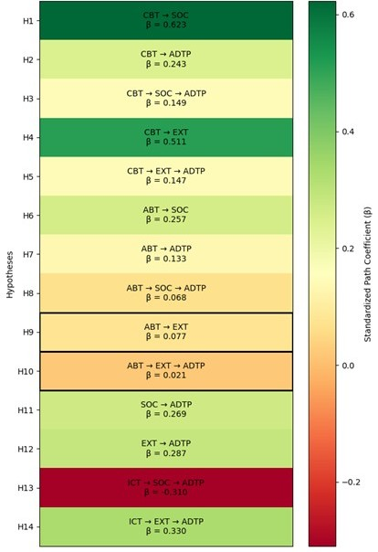
Figure 7: Heatmap of Structural Path Coefficients

Conclusion and Implications

Study Contributions
Theoretically, this study makes several contributions to the literature on trust dynamics, agile management, and knowledge-sharing processes. Firstly, by combining CBT and ABT as knowledge-sharing precursors, the study extends the SECI model by demonstrating that trust dimensions activate knowledge conversion processes in distinct ways, rather than uniformly. Secondly, the study advances trust research in distributed agile teams, where interpersonal communication is scarce due to distance and reliance on digital tools. By examining competent and emotional trust, the study clarifies their process-specific roles across SOC and EXT. Thirdly, it aligns the knowledge management theory with agile team performance outcome by linking the SECI-based knowledge process directly to ADTP. Past research has treated agility as a methodical procedure; however, this study bridges the knowledge-sharing theory by reframing agility as grounded in the SECI-based knowledge conversion process shaped by trust and ICT affordances. Finally, this study provides empirical evidence from the underexplored Pakistani IT industry, strengthening the understanding of boundary-conditioned interactions among trust, ICT, and knowledge-sharing in an emerging economy context. This research contributes to the theory relating to boundary-conditioned interactions among trust, ICT, and knowledge-sharing, specifically in an emerging economy setting.
Practically, this study offers actionable implications for agile practitioners, particularly in developing country contexts such as Pakistan. Firstly, Project managers in Pakistan IT industry should prioritize cognitive-based trust for structured knowledge-sharing (externalization), particularly in teams dominated by technical roles and mid-career professionals who emphasize task-oriented interaction over relational bonding. Secondly, the findings enable distributed team members to improve the knowledge-sharing processes within ICT-mediated environments in Pakistan’s software houses. Specifically, distributing tacit knowledge through collaborative learning and explicit knowledge through documentation and knowledge-conversion guidelines helps to limit technical redundancy. Finally, the study provides practical directions for reducing IT project failure by improving documentation practices, trust alignment, and ICT-supported knowledge-sharing. This study supports management approaches with agile principles to improve project quality and strengthen competitiveness in global markets.

Limitations and Future Research
This study has several limitations. Firstly, a cross-sectional design limits the ability to capture temporal changes and causal dynamics in trust in development and knowledge-sharing processes. Secondly, this research reveals the role of ICT as a moderator, indicating that different ICT configurations and varying levels of digital maturity across software firms may influence the observed relationships. Similarly, adopting alternative knowledge-sharing frameworks beyond the SECI model is likely to generate alternative perspectives and findings in future research. Thirdly, this study reports findings from the quantitative phase of a broader sequential explanatory mixed-methods study, while in-depth qualitative explanations are addressed in a subsequent research phase.
Future research may extend this work by providing in-depth qualitative explanations and adopting longitudinal or experimental designs to examine causal mechanisms and temporal dynamics. Future research may further refine the identified boundary conditions and strengthen the theory on trust, ICT, and knowledge-sharing in distributed agile teams.

Conclusion
The study demonstrated that CBT operating through knowledge-sharing processes (SOC and EXT) is a primary driver of ADTP, while ABT plays a more limited context-dependent role. Furthermore, ICT enhances structured knowledge and processes (EXT) but provides limited support for trust-based socialization (SOC), indicating that its effectiveness is process-specific rather than universal. Overall, the findings highlight that performance in distributed agile teams depends on aligning trust mechanisms, knowledge-sharing processes, and ICT use, particularly in emerging IT contexts such as Pakistan.
Declaration of Conflict of Interest, Ethical Compliance, and Use of AI Tools: The authors declare that there are no conflicts of interest related to the publication of this research. They confirm compliance with all ethical standards, addressing concerns such as plagiarism, research misconduct, informed consent, data fabrication or falsification, duplicate publication or submission, and redundancy. Additionally, the authors state that basic AI tools were used solely to assist with paraphrasing and proofreading during the writing process. All content was thoroughly reviewed and edited by the authors to ensure accuracy, originality, and academic integrity.

References
Abbas, A. ; Faiz, A. ; Fatima, A. and Avdic, A. (2017). Reasons for the failure of government IT projects in Pakistan: A contemporary study. pp. 1–6.
Ahmad, M.O. (2025). Strengthening large scale agile teams: the interplay of high quality relationships, psychological safety, and learning from failures. Journal of Software: Evolution and Process, 37(1), pp. e2759.
Alami, A. ; Krancher, O. and Paasivaara, M. (2022). The journey to technical excellence in agile software development. Information and Software Technology, 150, pp. 106959.
Alavi, M. and Leidner, D.E. (2001). Knowledge management and knowledge management systems: Conceptual foundations and research issues. MIS Quarterly, pp. 107–136.
Board of Investment. (2023). IT & ITeS sector profile. Pakistan. Available at https://invest.gov.pk/sites/default/files/inline-files/IT.pdf
Buvik, M.P. and Tkalich, A. (2022). Work engagement in agile teams: the missing link between team autonomy, trust, and performance. pp. 131–147.
Capestro, M. ; Rizzo, C. ; Kliestik, T. ; Peluso, A.M. and Pino, G. (2024). Enabling digital technologies adoption in industrial districts: the key role of trust and knowledge sharing. Technological Forecasting and Social Change, 198, pp. 123003.
Chen, Y. ; Yu, C. ; Yuan, Y. ; Lu, F. and Shen, W. (2021). The influence of trust on creativity: a review. Frontiers in Psychology, 12, pp. 706234.
Chin, W.W. (1998). Commentary: issues and opinion on structural equation modeling. In Modern methods for business research. Mahwah, NJ : Lawrence Erlbaum Associates.
Chowdhury, S. (2005). The role of affect- and cognition-based trust in complex knowledge sharing. Journal of Managerial Issues, 17(3), pp. 310–326.
Contreras-Medina, D.I. ; Nieto, E.S.D. ; Medina-Cuéllar, S.E. and Aguilar-Rivera, N. (2024). Ecocentrism for knowledge management and sustainability. London : Routledge.
Davidavičienė, V. ; Al Majzoub, K. and Meidute-Kavaliauskiene, I. (2020). Factors affecting knowledge sharing in virtual teams. Sustainability, 12, pp. 6917.
Dhir, S. ; Kumar, D. and Singh, V. (2018). Success and failure factors that impact project implementation using agile software development methodology.
Fornell, C. and Larcker, D.F. (1981). Evaluating structural equation models with unobservable variables and measurement error. Journal of Marketing Research, 18(1), pp. 39–50.
Hair, J.F. ; Risher, J.J. ; Sarstedt, M. and Ringle, C.M. (2019). When to use and how to report the results of PLS-SEM. European Business Review, 31(1), pp. 2–24.
Henseler, J. ; Ringle, C.M. and Sarstedt, M. (2015). A new criterion for assessing discriminant validity in variance-based structural equation modeling. Journal of the Academy of Marketing Science, 43, pp. 115–135.
Holste, J.S. and Fields, D. (2010). Trust and tacit knowledge sharing and use. Journal of Knowledge Management, 14, pp. 128–140.
Huber, S. ; Mühlroth, C. ; Zagel, C. ; Schwarz, S. and Bodendorf, F. (2016). Agile innovation management. Nuremberg : Lehrstuhl für Wirtschaftsinformatik.
Kanawattanachai, P. and Yoo, Y. (2002). Dynamic nature of trust in virtual teams. The Journal of Strategic Information Systems, 11(3–4), pp. 187–213.
Keeter, S. ; Kennedy, C. ; Dimock, M. ; Best, J. and Craighill, P. (2006). Gauging the impact of growing nonresponse on estimates from a national RDD telephone survey. International Journal of Public Opinion Research, 18(4), pp. 759–779.
Khan, S. and Rehman, S. (2025). Elevating sustainable business performance of IT enterprises via entrepreneurial agile antecedents in Pakistan. Journal of Entrepreneurship and Business Venturing, 5.
Kline, E. ; Wilson, C. ; Ereshefsky, S. ; Tsuji, T. ; Schiffman, J. ; Pitts, S. and Reeves, G. (2012). Convergent and discriminant validity of attenuated psychosis screening tools. Schizophrenia Research, 134(1), pp. 49–53.
Leal, W.E. ; Boccio, C.M. and Jackson, D.B. (2023). The interplay between virtual socializing, unstructured socializing, and delinquency. Crime & Delinquency, 69, pp. 1894–1918.
Lee, H. and Choi, B. (2003). Knowledge management enablers, processes, and organizational performance. Journal of Management Information Systems, 20(1), pp. 179–228.
Legood, A. ; Van der Werff, L. ; Lee, A. ; Den Hartog, D. and Van Knippenberg, D. (2023). A critical review of cognition-based and affect-based trust. Journal of Management Studies, 60, pp. 495–537.
Li, G. ; Rubenstein, A.L. ; Lin, W. ; Wang, M. and Chen, X. (2018). The curvilinear effect of benevolent leadership on team performance. Personnel Psychology, 71, pp. 369–397.
Lurey, J.S. and Raisinghani, M.S. (2001). An empirical study of best practices in virtual teams. Information & Management, 38(8), pp. 523–544.
Mannheim, K. (1952). The sociological problem of generations. In Essays on the Sociology of Knowledge.
Maznevski, M.L. and Chudoba, K.M. (2000). Bridging space over time: Global virtual team dynamics and effectiveness. Organization Science, 11(5), pp. 473–492.
McAllister, D.J. (1995). Affect- and cognition-based trust as foundations for interpersonal cooperation in organizations. Academy of Management Journal, 38, pp. 24–59.
Ministry of Information Technology and Telecommunication. (2020). Pakistan’s IT industry overview. Available at https://moitt.gov.pk/SiteImage/Misc/files/Pakistan%27s%20IT%20Industry%20Report-Printer.pdf
Müller, D. ; Judd, C.M. and Yzerbyt, V.Y. (2005). When moderation is mediated and mediation is moderated. Journal of Personality and Social Psychology, 89(6), pp. 852.
Müller, R. and Antoni, C.H. (2022). Effects of ICT shared mental models on team processes and outcomes. Small Group Research, 53, pp. 307–335.
Mustaqeem, S.A. ; Khalid, R. and Nabi, S.I. (2020). Project management maturity in Pakistan: An empirical investigation. Business Review, 15(1), pp. 67–82.
Nonaka, I. ; Takeuchi, H. and Umemoto, K. (1996). A theory of organizational knowledge creation. International Journal of Technology Management, 11, pp. 833–845.
Pinjani, P. and Palvia, P. (2013). Trust and knowledge sharing in diverse global virtual teams. Information & Management, 50, pp. 144–153.
Politis, J.D. (2003). The connection between trust and knowledge management. Journal of Knowledge Management, 7, pp. 55–66.
Project Management Institute. (2021). A guide to the project management body of knowledge (PMBOK® guide)–Seventh edition and the standard for project management. Newtown Square, PA : Project Management Institute.
Rahman, M.M. (2023). Sample size determination for survey research. Journal of Entrepreneurship, Business and Economics, 11, pp. 42–62.
Razzak, M.A. ; Bhuiyan, T. and Ahmed, R. (2014). Knowledge management in distributed agile software development projects. pp. 107–131.
Santana, B. ; Monte, L. ; Araújo Silva, B.S. de ; Carneiro, G. ; Freire, S. ; Santos, J.A.M. and Mendonça, M. (2025). Psychological safety in software workplaces: A systematic literature review. Information and Software Technology, pp. 107838.
Schulze, A. and Hoegl, M. (2008). Organizational knowledge creation and the generation of new product ideas. Research Policy, 37, pp. 1742–1750.
Swift, P.E. and Hwang, A. (2013). The impact of affective and cognitive trust on knowledge sharing and organizational learning. The Learning Organization, 20, pp. 20–37.
Trochim, W. ; Kane, C. ; Graham, M.J. and Pincus, H.A. (2011). Evaluating translational research. Clinical and Translational Science, 4, pp. 153–162.
Tyagi, S. ; Sibal, R. and Suri, B. (2018). Role of trust in distributed agile software development teams. ICTACT Journal on Management Studies, 4, pp. 748–753.
Umar, A. ; Sarkingobir, Y. ; Dikko, M. ; Miya, Y.Y. and Salah, N.M. (2023). Effect of anemia on cognitive capacity of adult students in Sokoto, Nigeria. Journal of Health Sciences, 16, pp. 157–162.
Vehovar, V. ; Toepoel, V. and Steinmetz, S. (2016). Non-probability sampling. In The Sage handbook of survey methods. London : Sage.
Wafa, R. ; Khan, M.Q. ; Malik, F. ; Abdusalomov, A.B. ; Cho, Y.I. and Odarchenko, R. (2022). The impact of agile methodology on project success. Applied Sciences, 12, pp. 10698.
Wahbeh, N. ; Admodisastro, N. ; Hassan, S.A. and Abdullah, S. (2024). Requirement change management in global software development: a systematic review.
Waheed, S. ; Hamid, B. ; Jhanjhi, N. ; Humayun, M. and Malik, N.A. (2019). Improving knowledge sharing in distributed software development. International Journal of Advanced Computer Science and Applications, 10.
Zong, Z. and Guan, Y. (2025). AI-driven intelligent data analytics and predictive analysis in Industry 4.0. Journal of the Knowledge Economy, 16, pp. 864–903.

Appendix A: Survey Instrument
Cognitive-based Trust
The majority of my team members approach their jobs professionally and with commitment.
I have no reason to question the skill and competence of my team members for the task.
I can trust my team members not to complicate my task by performing irresponsible work.
The majority of my team members consistently follow through on their commitments as they have promised.
Affect-based Trust
I can communicate openly with my team about challenges I'm facing at work, confident that they will want to listen.
If one of us were relocated and together we were unable to continue, I would experience a feeling of loss.
If my team were aware of my concerns, I am convinced that they would respond with consideration and constructiveness.
I have to admit that my team has made significant emotional investments in our professional relationship.
Socialization
I spent a great deal of time outside of formal meetings with other team members discussing recommendations, ideas, and solutions.
Aside from formal meetings, I spent a great deal of time interacting with team members from different departments inside the organization in order to discuss recommendations, ideas, and solutions.
In face-to-face meetings with project/team leaders from other teams of the company, I spent a great deal of time in lengthy discussions about recommendations, ideas, or solutions.
With team members from various company teams, I spent a great deal of time intentionally developing a shared understanding of a problem.
Externalization
I spent a great deal of time collaboratively reflecting and formulating our thoughts or solutions in terms of customer requirements.
I spent a great deal of time speaking with knowledgeable people in order to get their suggestions for useful technological thoughts or solutions.
I spent a great deal of time interviewing knowledgeable people about thoughts or solutions related to customer requirements.
I spent a great deal of time developing comprehensive descriptions (e.g., protocols, presentations, and reports) containing newly acquired knowledge about customer requirements.
Information and Communication Technology
I have access to all of the data necessary to accomplish my duties.
The team has the necessary tools and technology to do our jobs.
Team members often communicate with one another in order to accomplish everyday business.
Team members are often in contact with one another for social or non-business activities.
The electronic means we employ to communicate with one another are efficient.
Agile Distributed Team Performance
In the past, the agile team has been successful in achieving its objectives.
The agile team is accomplishing its existing business objectives.
Generally, the agile team accomplishes its task on schedule.
Generally, the agile team accomplishes its task on a budget.
Within the agile team, there is respect for team members.
I believe my contribution is recognized by team members.
Team members have a high level of spirit.
I appreciate being a part of this team.
I would be eager to join another distributed agile team in the future.

